September 23rd, 2006
Hi
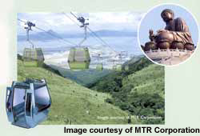
Not much to write about again. It has been a very busy week with proof reading for the revised Singapore science book. Yesterday, I worked all day until midnight doing proof reading. The editors still have a lot of work to do and the deadline for handing in the books is at the end of this month – just a week away! The deadline should have been in November, but the publisher messed up when sending in the initial information for approval to revise the book. They could have been rejected entirely but instead were ‘punished’ instead by having to have the work done two months earlier than others! Proof reading is not a job I usually like as there are so many ‘stupid’ mistakes even with very good editors. Courier mail of manuscripts has been going on all the past week. After finishing this letter, I will have to do some more proof reading – the last I hope!
The Lantau cable car system opened last Monday after a delay of three months because it kept of breaking down. The first day of operation was yesterday, but believe it or not, it had to stop operating again, but only for a brief time, due to strong winds.
Did more swimming distance this week than in other weeks. I swam on three days and did a total of 9 km, and on one of these days did 4 km, which took about 1 hr 50 mins!
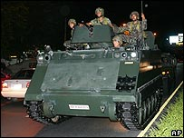
You probably heard about the army coup d’etat in Thailand, ousting the PM and government. In the circumstances, this was probably the best outcome as the PM was abusing his office, was authoritarian, was padding his extensive businesses interests and was surrounding himself with cronies. Unfortunately, the country did not have any systems in place to deal with this. The PM is now in London and will probably stay there for some time. (The UK seems to be a safe haven for many a deposed leader with people from all over the world there, even now.)
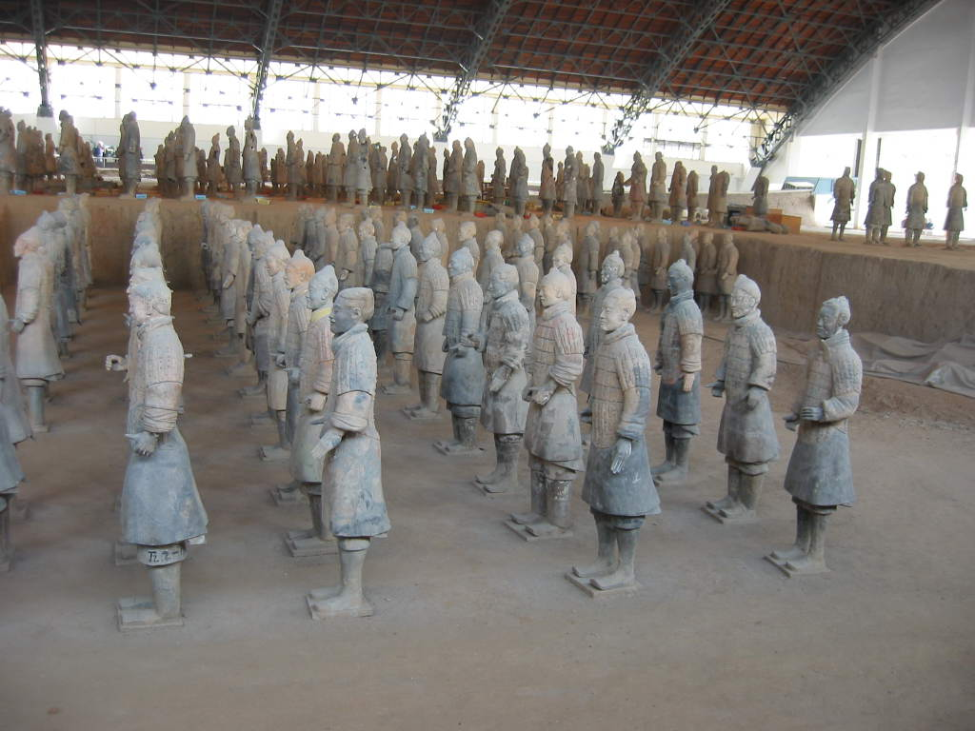
A few days ago, a Westerner dressed up to look like one of the 2200 year-old terra-cotta warriors in China. He hid amongst the statues. Although seen entering, it was a long time before he could be found as his costume was very realistic and he was able to stand absolutely still. He was given a warning but they kept his suit!

On Tuesday, I go to the Tuen Mun clinic again for another minor biopsy for a ‘suspicious’ pimple-like growth. It is so small that, even if it turns out to be cancerous, the biopsy will probable be able to remove all of it,

That’s about it! Not very much.
Cheers

